## Merchant Name: Taktile Implementation POC: Ali *(IM to fill)* CX POC: *[IMP to Add]*

### ***SOW outlining Scoped Workflows for US Entity and German Entity:*** [https://docs.google.com/document/d/c1rBAXNoz3bw9PLsKUrW_Wzdar7wQru2Yl/edit?usp=sharing&ouid=104111395452325218200&rtpof=true&sd=true](https://docs.google.com/document/d/1rBAXNoz3bw9PLsKUrW_Wzdar7wQru2Yl/edit?usp=sharing&ouid=104111395452325218200&rtpof=true&sd=true)

### 

| Notes Sections   *(AE to fill if they have, Implementation to be completion DRI on handoff)*   * Info on how merchant bills   Flat Platform Fee is 95% of their billing, the other 5% is PxQ usage that they will upload via CSV. Payment terms are monthly, quarterly, or annually.  1) What is the merchant temperament?  The entire finance team is based in Germany (6 hours ahead of NYC). There were 5 stakeholders involved in their deal: Katjana (VP of Finance, Champion/Decision Maker), Isida (Controller, Influencer), Katja (Accounting Lead, Influencer), Nikolas (Technical Finance Lad, Influencer), and Alex (CFO, Executive Buyer).  Isida will be the main power user of Tabs. She ran the POC and oversees all billing and collections. Katjana is her boss and will be involved, more of an overseeing role and not involved in the day to day. Katja and Niko will not be on first kickoff but will be involved with Tabs. Alex most likely will take a backseat to everything and let his team run with Tabs.  Very nice team and extremely excited about Tabs. One thing to call out is they are German so there are some cultural differences (i.e. being on time always, very blunt and say what they want but open to working together to a solution)  3) What are the Tabs features that the key POC cares about?   1. Contract Management - grew 4x last year and are planning for the same growth this year. Simple contracts, but high volume that makes it hard to track key terms and differences across contracts. 2. Billing and Collections. Payment Terms can be monthly, quarterly, or annually with discounts. They are manually sending all invoices in QBO and from their German ERP. High volumes and missing/miscalculating invoices consistently. 3. Stripe integration. Ability to push stripe fees onto US customers is a huge ROI advantage for them. Currently getting knocked with high processing fees as they grow 4. Cash Application. Matching payments to invoices is all manual today. This feature specifically will save them days of time during close. |
| --- |

### Billing model *(Entire Section: Implementation to fill section)*

* Are there unique things about the customer creation process for this merchant?
* Information on how merchant bills
* How contract is broken up
* One off things to know about the merchant

### Contract Processing Steps *(Entire Section: Implementation/Success to fill Post-Go Live)*

* **General**
  + Do not process $0 or waived BTs
  + Will need to prorate first and last of term invoices for contracts that don’t start on the first of the month so that billing for the rest of the contract can start on the first.
  + If you see a Reseller Agreement, please process no BTs
* **Invoice Additional Fields:**
  + Populate [this sheet](https://docs.google.com/spreadsheets/d/15DR4pFiR4689eYqynfj5MFCADerYZLSzcXe-tjUIuWU/edit?usp=sharing) with billing email and tax ID. also enter the customer name and ID
  + If they aren’t available, no need to add
    - VAT #: use the Tax-ID
      * 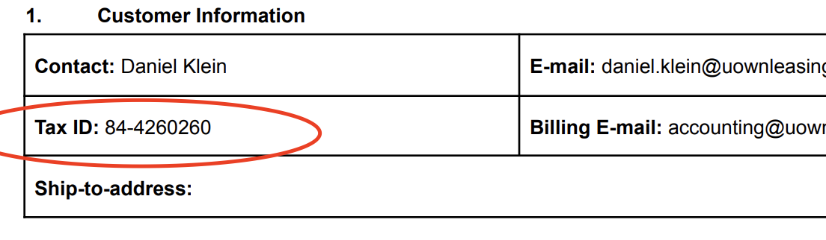
    - Billing Email
* 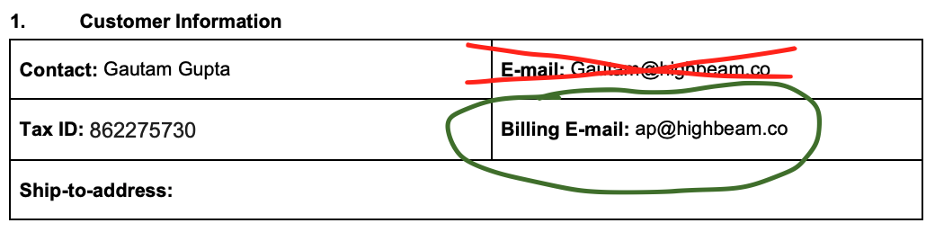
  + - CC Emails
      * If there are multiple Billing emails or CC emails, please add all of them on the billing emails section in the customer page in garage
    - Is there a shipping address (yes or no)
* **Customer Creation and Correct:**
  + Customers should already exist, but if they do not, we can create
    - Per the above screenshot, make sure you use *billing email* not the regular email
  + If the customer DOES exist
    - Need to double check the customer in garage (can also click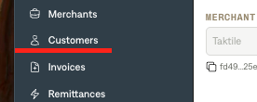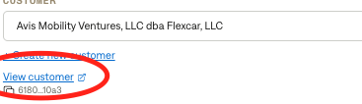
      * Check the *billing email and address*
      * If the contract has a different billing email or address, correct the customer information
        + Their system has incorrect information and they want the source of truth to be the contract
        + Make sure to add both billing emails if available
  + If the customer DOESN’T exist
    - Make sure you use billing email if available
      * If there are multiple billing emails, please include both
        + You will have to create the customer with one billing email and then add the second one in garage (click view customer)
      * If not listed, use the next available email address
    - Use the ship-to-address if available
      * If not listed, use the next available address
* **Prorating (ONLY FOR MONTHLY BTs):**
  + Instructions if billing doesn’t start on the first of the month
    - If the contract starts on the last day of the month
      * Start the BT on the next first of the month - can ignore prorating.
        + Can start both billing and service start date on the 1st of the month
  + [Example](https://garage.tabsplatform.com/prod/contracts/20c893de-3ff6-4af5-8296-69dc56ef7ef3/terms/revenue)
  + Create a BT for the prorated first month
    - Do the proration calculation for # of days in the month
    - Frequency: number of days left
      * Type in the number of days until Calculated end date is equal to the last day of the month
    - Months of service: 1
    - Item name: add “(First Month Prorated)” to the end
    - Service start date = billing start date = contract start date
  + The main BT should start on the first of the next month (both service start date and billing start date)
    - Months of service: whatever contract length is minus 1 (will be 11 a lot of the time)
    - # of periods will be the same as months of service
    - Frequency will be months
    - Regular monthly BT amount for price
    - Service start date = billing start date = next first of the month
  + The third last month BT
    - Name: add “(Last of Month Prorated)” to the end
    - Proration calc should be normal BT amount minus the first month prorated amount (equals the remaining prorated amount to be billed)
    - Frequency: the # of days in the month minus the number of days the first month prorated BT had for frequency
    - Months of service = 1
    - Service start date = billing start date = last month on the 1st of the month
* **Item Name:**
  + Use the name listed in the item description. *Abbreviate lengthy descriptions* using best judgement
    - Example: Item Name is “Decision Package Fee including up to 18,000 decisions per annum for credit underwriting use case”
      * Use “Decision Package Fee for credit underwriting”.
* **Total Price:** Use the amount listed for that service period.
* **Service Start Date (follow proration instructions instead if they apply)**
  + Use the "Start Date" listed in the subscription term section for each contract.
  + For individual BTs (year 1, year 2-3, etc.), use the exact date that they start
    - So year 1 would be 1/1/2025
    - Year 2 would be 1/1/2026
  + If Implementation Date is referenced as a trigger for service start, use that instead.
* **Billing Start Date (follow proration instructions instead if they apply)**
  + Same as service start date
* **Months of Service:** “Duration”
* **Frequency:** use the “unit” column
* **Net Terms**
  + Will need to search the contract
    - Key words to search
      * “Within” = within 14 days or within 30 day
      * “Days”
      * “Due”
  + If not specified, default to Net 30.
* **Additional Terms**
  + Make sure to follow the Additional Terms section as it will lay out specific discounts and usage BTs that aren’t present in the BT table
    - [Example](https://garage.tabsplatform.com/prod/contracts/3c725bfb-be35-49fe-a93a-d703f3b23757/preview): “Taktile agrees to offer a discount to the Taktile Fees bringing the total annual amount due of $20,000. This discount is valid for the first 12 months of the initial Subscription Term. In the first twelve months of the Subscription Term, the Decision Package is not applicable and Decisions will be charged on a per Decision base at the rate of USD 0.1 per Decision. In year 2 and year 3 of the Subscription Term (if applicable), the Fees for both the Taktile Platform and the Decision Package will be reduced to a total of ($90,000), annually.”
      * In this example, the BTs were discounted evenly according to this section
      * Had to calculate the % discount by taking the BT total 115,200 and dividing 90,000 by it to figure out what the % discount was and then applied that to each individual BT (21.875% discount)
  + This section will override other information - follow it exactly
* **Integration Items**
  + Use [this mapping](https://docs.google.com/spreadsheets/d/1MLcpHAeaqlecvd9LugJ-_5uA_cY-JKOcaubLmcTOfBw/edit?usp=sharing)
* **Usage BTs**
  + Look out for “overage” terms that require a tiered usage BT
  + [Example](https://garage.tabsplatform.com/prod/contracts/faa7254e-804d-45ab-9e6f-93a99205455f/terms/revenue)
    - “Kickstarter Decision Package Fee for Credit Underwriting Use Case including up to 200,000 decisions per month”

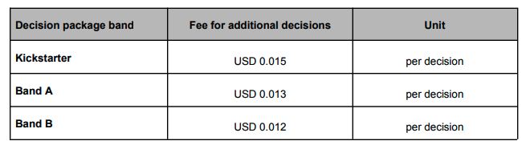

* + - Would set up a tiered usage BT for the overage amount $0.015 for anything above 200,001 decisions
    - If there are prorated BTs on the contract, the usage BT needs to start on the first of the month that the contract start and go for the length of the contract
      * In this example, contract starts on March 4, 2024 and goes for 12 months, so for this usage BT:
        + Billing start date: March 1, 2024
        + Service start date: March 4, 2024; months of service: 12
        + # of periods: 12; frequency: months
* **Auto renewal**
  + Command F search “auto” - if you see a clause like the below that says the contract will auto renew, extend the BTs another term (i.e. 24 months instead of 12)
    - “Each Subscription Term shall renew automatically for succeeding terms of one (1) year each, on the same terms that are in place on the renewal date excluding any discounts”
  + This means you would have to change the proration processing accordingly
* **Other Rules**
  + Watch out for FNs and be sure to incorporate
    - 
    - It will often have a discount attached in the FN
  + Do not process Decision Package line items on go-live contracts until go-live.
    - Command F search “go live” to see if there is a go live clause
    - Default ~2 month + start date (start on the next first of the month)
      * If contract start date is 7/5/25, start the decision package on 9/1/25
      * Ignore prorating
    - Ignore usage tiers unless pricing indicates overage charges (e.g., per-decision fees)

1. Anything to ignore in contracts?
2. Specifics processing things the merchant has requested that may differ by contract (e.g. always back-date invoice date to final day of the month)
3. Default Service Term
   1. If None Listed, Ops Default is 1 Year
4. Default Net Payment Terms
   1. If None, Ops Default is 0
5. Default Billing Frequency
   1. If None Listed, Ops Default is Monthly
6. How do we handle taxes as a line item?
   1. If None Listed, Ops Default is every tax line item becomes a BT

### Events Processing (if necessary) *(Entire Section: Implementation/Success to fill Post-Go Live)*

* Any important information on events billing

Integration Items Processing (if necessary)  
*(Entire Section: Implementation/Success to fill Post-Go Live)*

* What are the instructions for assigning integration items?
* Example: All Statsig integrations items should be labeled as “Sales”
* Example: All “Pinata” integration items should be labeled as “Software Subscription Bundle” unless otherwise noted by Merchant

Post Processing Communications (if necessary)  
*(Entire Section: Implementation/Success to fill Post-Go Live)*

* Does the Ops Team need to notify anyone on the team re: completion of processing batches in Implementation or Active phase?
* Who needs to be notified and when?
  + Example:
    - Who: Customer Success [Azmat Aziz] needs to be notified
    - Where: Messari internal merchant channel
    - When: contracts are processed [Merchant Phase: Active]

### Customer Information *(Entire Section: Implementation/Success to fill Post-Go Live)*

* Any important information on specifics customers of this merchant
  + Special memo’s certain invoices require
  + Invoice changes due to merchant/customer relationship

### Feature Requests *(AE to fill for all requests prior to Imp handoff, Imp to fill prior to go-live/Success to fill to fill Post-Go Live)*

* International Cash App and JE Support
  + They have a German Entity that handles their European customers
  + We’ve aligned on the export from Tabs being okay and they will touch up the export for dates, taxes, ETC
  + Low - Not in original SOW but would be a huge ROI save for them
* Cohort Reporting
  + Potentially changing pricing models and want a way to cohort customers by pricing model
  + New CFO and Technical Lead are data driven and want the ability to segment customer reporting in Tabs more granularly
  + Medium - will not be using reporting in Tabs because of this. Great way to drive more users and ROI on the platform

### Merchant Calls *(AE to fill for all videos prior to Imp involvement, Imp to fill prior to go-live/Success to fill to fill Post-Go Live)*

* Disco 2/19
  + https://us-56595.app.gong.io/call?id=6972884073682882286
* Demo, Integrations, Implementation 3/11
  + https://us-56595.app.gong.io/call?id=364622503887384000
* Workflows Alignment 3/26
  + <https://us-56595.app.gong.io/call?id=2726541699265701039>
* POC Set Up 4/16
  + <https://us-56595.app.gong.io/call?id=7560211037574228463>
* POC Working Session 4/17
  + <https://us-56595.app.gong.io/call?id=6080172196537424679>
* POC Wrap Up 4/22
  + <https://us-56595.app.gong.io/call?id=2036394660017877002>
* Systems, Reporting, Implementation 4/28
  + <https://us-56595.app.gong.io/call?id=7053578045975928257>
* Partnership Alignment, Intro to Niko 5/9
  + <https://us-56595.app.gong.io/call?id=2911882097926075075>
* Technical Demo and POC 5/13
  + <https://us-56595.app.gong.io/call?id=4071649813250636243>
* Technical Wrap Up 5/14
  + <https://us-56595.app.gong.io/call?id=7887534056743952635>
* Commercial Feedback and Path to Partnership 5/21
  + <https://us-56595.app.gong.io/call?id=1803321710222411804>
* SOW REview 6/11
  + <https://us-56595.app.gong.io/call?id=1018473801966394969>